**WARNING: Taking these common painkillers increases risk of heart failure by almost 20%**

**IF YOU pop a pill every time you get a headache you could be increasing your risk of heart disease by a fifth.**

|  |  |  |  |  |  |  |  |  |  |  |  |  |  |  |  |  |  |  |  |  |  |
| --- | --- | --- | --- | --- | --- | --- | --- | --- | --- | --- | --- | --- | --- | --- | --- | --- | --- | --- | --- | --- | --- |
| |  |  |  | | --- | --- | --- | |  | http://cdn.images.dailystar.co.uk/img/static/icons/share2/facebook.png |  | | |  |  |  | | --- | --- | --- | |  | http://cdn.images.dailystar.co.uk/img/static/icons/share2/twitter.png |  | | |  |  |  | | --- | --- | --- | |  | http://cdn.images.dailystar.co.uk/img/static/icons/share4/googleplus.png |  | | |  |  |  | | --- | --- | --- | |  | http://cdn.images.dailystar.co.uk/img/static/icons/share2/comments.png |  | | |  |  |  |  |  | | --- | --- | --- | --- | --- | | |  |  |  | | --- | --- | --- | |  | http://cdn.images.dailystar.co.uk/img/static/icons/share2/share.png |  | | 1 | |

**By**[**Laura Mitchell**](http://www.dailystar.co.uk/journalists/laura-mitchell)/**Published 29th September 2016**

GETTY

WARNING: Taking these pills can increase your risk of heart failure

Ibuprofen has been linked to heart failure, a major scientific study revealed today.

The popular everyday painkiller is used by millions of Brits to ease headaches, menstrual cramps and back pain.

But new research suggests common anti-inflammatory drugs like Ibuprofen can increase the chance of potentially-deadly heart disease.

ADVERTISING

[inRead invented by Teads](http://inread-experience.teads.tv/)

[*** The silent sign of heart disease you should NEVER ignore ***](http://www.dailystar.co.uk/real-life/546939/Symptoms-heart-disease-pain-chest-going-bed-early)

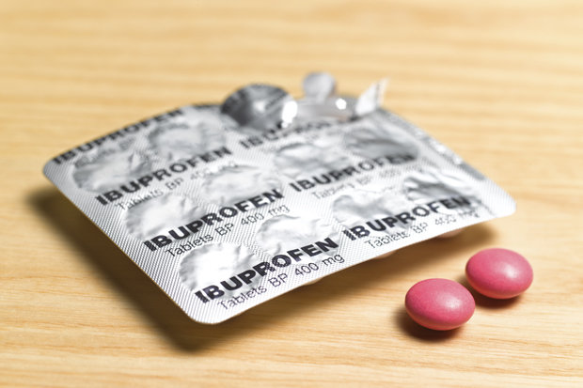GETTY

DANGER: Anti-inflammatory drugs like Ibuprofen can increase the chance of heart disease

The study found patients who regularly take the pills are up to 19% more likely to develop heart failure.

Long-term use of the medication causes chemical reactions in the body which place extra strain on the heart, the research found.

This can lead to heart failure in patients who have a history of previous heart attacks or high blood pressure